# Technical report: Third workshop advanced programming

Name: Carlos Alberto Barriga Gámez Code: 202220202179

**User stories**

-As a customer I want to have access to a menu to be able to give the specifications of the vehicle I want to buy.

-As a customer I want to have an option in the menu called engine type, to define the type of engine I want in my vehicle.

-As a customer I want to have options in the menu to choose each available vehicle, to create the vehicle I want to buy.

-As a customer I want to have the option in the menu to review the vehicle I have designed, to verify the complete characteristics of the vehicle.

-As an administrator, I would like to have the option to review the vehicles created so far, to determine which vehicles the company offers.

-As an administrator, I want to have the option to review the engines created so far, to determine which engines the company offers.

-As a user (Admin, Customer) I want to have a way to log in, to identify myself in a unique way in the system.

Class diagram

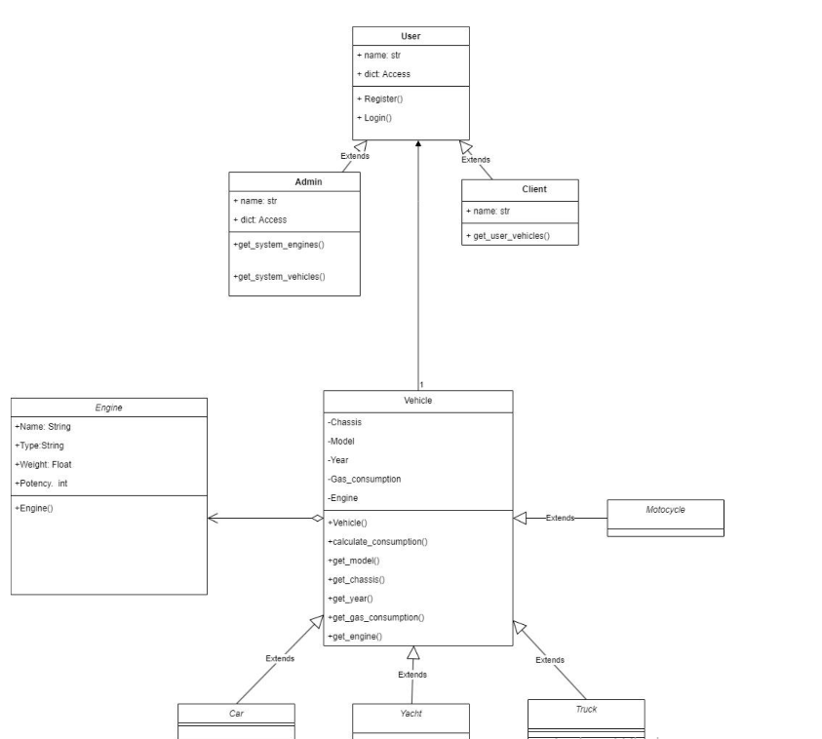

**Activity diagrams**

**Create a engine**

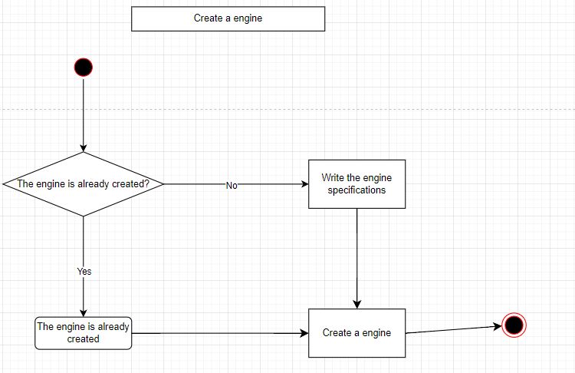

**Create a vehicle**

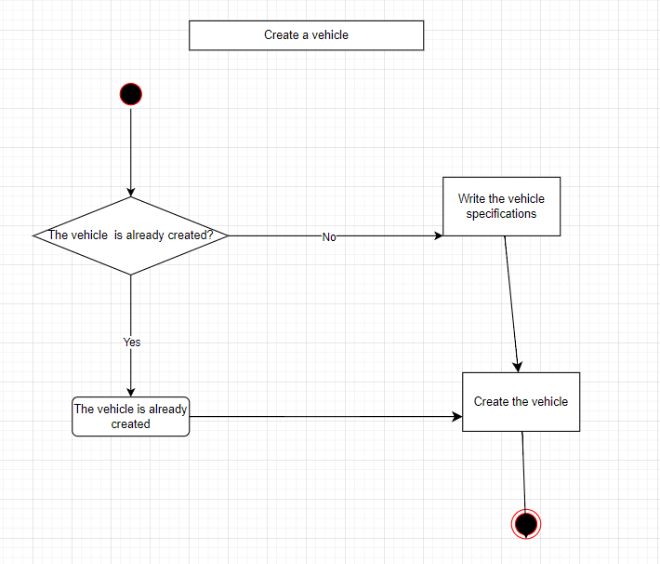

**Show vehicle**

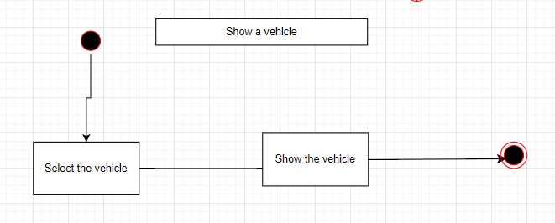

**Show engine**

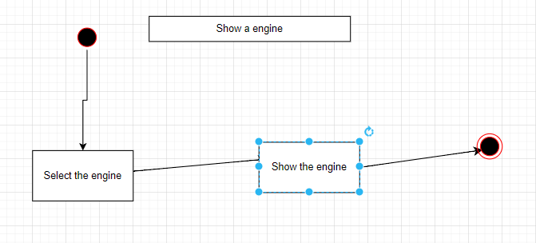

**Login**

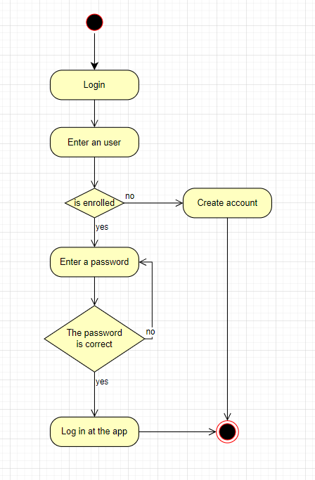

**UI Prototypes:**

